We are currently in the Content Gathering Phase, where we are instructed to use GenAI to generate text for your articles.
Below is the text content generated for every page listed in the project breakdown, organized by Developer/Role.

⚠️ Important Project Rule Reminder
According to the Strict Technical Rules in your document: NO AI CODE..
- You may use the text below for your content.
- You must write the HTML/CSS tags yourself.
- Remember to put your name in a comment at the top of every file.

👑 LEADER: Site Hub & General Info

1. Page: index.html (Landing Page)
Headline: Welcome to SmartCity: Your Guide to Sustainable Living Introduction: Welcome to SmartCity, the educational hub dedicated to teaching you how to make your home and life more eco-friendly. In a world facing climate challenges, small individual actions create massive collective change. Navigation Overview: Explore our five core modules to begin your journey: Energy (Renewables & Efficiency), Waste (Recycling & Reduction), Water (Conservation), Transport (Green Mobility), and Lifestyle (Ethical Choices). Call to Action: Start exploring today and lower your carbon footprint one step at a time.

2. Page: news.html
Headline: Sustainability News & Updates Article 1: Global Shift to Renewables. Recent reports indicate that solar and wind energy are now cheaper than coal in most major economies. Cities are adopting "Smart Grids" to manage this power more efficiently. Article 2: The Rise of the Circular Economy. Major brands are moving away from "take-make-waste" models. New legislation pushes for "Right to Repair," ensuring electronics last longer and stay out of landfills.

3. Page: about_sustainability.html
Headline: What is Sustainability? Definition: Sustainability means meeting our own needs without compromising the ability of future generations to meet their own needs. It is not just about the environment; it is also about social equity and economic vitality. Why It Matters: From reducing greenhouse gas emissions to preserving fresh water, sustainable living ensures that our planet remains habitable and healthy. SmartCity aims to bridge the gap between complex science and actionable daily habits.

⚡ DEV 1: Module ENERGY

1. Page: energy_solar.html
Headline: Understanding Solar Energy: Power from the Sun Content: Solar photovoltaic (PV) panels convert sunlight directly into electricity. By installing panels on your roof, you can generate your own clean power, reducing reliance on the fossil-fuel-heavy grid. Modern systems are durable, often lasting 25+ years, and can significantly lower monthly utility bills while increasing property value.

2. Page: energy_insulation.html
Headline: Home Insulation: Keeping Heat In (and Out) Content: The cheapest energy is the energy you don't use. Proper insulation acts as a thermal barrier, keeping your home warm in winter and cool in summer. Key areas to insulate include the attic, walls, and floors above unheated garages. upgrading insulation reduces the workload on your HVAC system, extending its lifespan.

3. Page: energy_lighting.html
Headline: LED vs. Incandescent: The Bright Choice Content: Lighting accounts for a significant portion of home electricity use. Traditional incandescent bulbs waste 90% of their energy as heat. Light Emitting Diodes (LEDs) use up to 75% less energy and last 25 times longer. Switching all bulbs in a home to LEDs is one of the fastest ways to reduce your carbon footprint.

4. Page: energy_monitor.html
Headline: Smart Meters & Energy Monitoring Content: You cannot manage what you do not measure. Smart meters and home energy monitors provide real-time data on your electricity usage. These devices can identify "energy vampires"—appliances that drain power even when turned off—and help you adjust habits to save money during peak pricing hours.

5. Page: energy_tips.html
Headline: Daily Habits for Energy Efficiency Content: Saving energy doesn't require renovation. Simple habits make a difference:
- Wash clothes in cold water.
- Air-dry dishes and laundry when possible.
- Turn off lights when leaving a room.
- Unplug electronics when not in use.
- Adjust your thermostat by 1-2 degrees.

♻️ DEV 2: Module WASTE

1. Page: waste_compost.html
Headline: Composting 101: Turning Scraps into Soil Content: Composting recycles organic matter into a valuable fertilizer. To start, you need a balance of "Greens" (nitrogen-rich vegetable scraps, coffee grounds) and "Browns" (carbon-rich dried leaves, paper). This process diverts food waste from landfills, where it would otherwise generate methane, a potent greenhouse gas.

2. Page: waste_recycling_rules.html
Headline: Know Your Codes: A Guide to Recycling Content: Not all plastic is recyclable. Look for the resin identification code (triangle number) on the bottom of containers.
- #1 (PET) & #2 (HDPE): Widely recyclable (Bottles, jugs).
- #3 (PVC) through #7: Often difficult to recycle.
- Rule of Thumb: Clean and dry your recyclables. Food contamination can ruin an entire batch of recycling.

3. Page: waste_upcycling.html
Headline: Upcycling: Creativity Over Waste Content: Upcycling involves transforming unwanted products into new materials of better quality or environmental value. Unlike recycling, which breaks materials down, upcycling refashions them. Examples include turning old pallets into furniture, using glass jars for storage, or turning t-shirts into tote bags.

4. Page: waste_plastic_alts.html
Headline: Breaking Up with Single-Use Plastics Content: Plastic pollution is a global crisis. We can reduce demand by choosing alternatives:
- Beeswax Wraps: Replace plastic cling film.
- Bamboo/Metal Straws: Replace plastic straws.
- Glass Containers: Safer for food storage than plastic.
- Bar Soap: Eliminates plastic body wash bottles.

5. Page: waste_hazards.html
Headline: Hazardous Waste: Batteries and Electronics Content: Never throw batteries, electronics (e-waste), or chemicals in the regular trash. They contain heavy metals like lead and mercury that can leach into groundwater. Locate your local designated "Hazardous Waste Drop-off" center or look for retail stores that offer battery take-back programs.

💧 DEV 3: Module WATER

1. Page: water_harvesting.html
Headline: Rainwater Harvesting: Catching the Flow Content: Rain barrels collect water from rooftops via gutters. This water, while not potable (drinkable) without treatment, is perfect for watering gardens, washing cars, or cleaning outdoor surfaces. Harvesting rainwater reduces stormwater runoff, which can cause erosion and carry pollutants into local waterways.

2. Page: water_fixtures.html
Headline: Low-Flow Fixtures: Save Water Automatically Content: Installing low-flow aerators on taps and switching to low-flow showerheads can reduce water usage by 30-50% without sacrificing pressure. Dual-flush toilets are another excellent upgrade, allowing users to choose a smaller flush volume for liquid waste, saving thousands of liters per year.

3. Page: water_garden.html
Headline: Xeriscaping: Drought-Resistant Gardening Content: Xeriscaping is landscaping designed to reduce or eliminate the need for irrigation. It involves choosing native plants that are adapted to the local climate. These plants require less water, no chemical fertilizers, and less maintenance than a traditional grass lawn.

4. Page: water_filtration.html
Headline: Home Water Filtration Explained Content: Filtering tap water at home is more eco-friendly than buying bottled water.
- Activated Carbon: Removes chlorine and improves taste (pitchers/fridge filters).
- Reverse Osmosis: Removes a wide range of contaminants but produces wastewater.
- Ceramic Filters: Good for bacteria and sediment removal.

5. Page: water_drought.html
Headline: Understanding Your Water Footprint Content: Your water footprint includes not just the water you drink or shower with, but the "virtual water" used to produce your food and clothes. For example, producing 1kg of beef requires 15,000 liters of water. Awareness of these hidden costs helps us make better consumption choices during drought conditions.

🚲 DEV 4: Module TRANSPORT

1. Page: transport_ev_guide.html
Headline: The Electric Vehicle (EV) Revolution Content: Electric vehicles produce zero tailpipe emissions.
- BEV (Battery Electric Vehicle): Runs entirely on electricity.
- PHEV (Plug-in Hybrid): Has a battery for short trips and a gas engine for long range.
- Charging: Most charging happens at home overnight, though public fast-charging networks are expanding rapidly.

2. Page: transport_biking.html
Headline: Cycling: Pedal Your Way to Health Content: Biking is the most energy-efficient mode of transport. It produces zero pollution and provides cardiovascular exercise. Essential safety gear includes a well-fitted helmet, lights for visibility, and reflective clothing. Always follow local traffic laws and utilize dedicated bike lanes where available.

3. Page: transport_public.html
Headline: The Benefits of Public Transit Content: Taking a bus or train replaces dozens of individual cars on the road. This significantly reduces traffic congestion and smog. Public transportation is also statistically safer than driving and allows passengers to read or work during their commute, reclaiming lost time.

4. Page: transport_carpool.html
Headline: Carpooling: Sharing the Ride Content: Carpooling maximizes the utility of a vehicle. If four people share a ride, there are three fewer cars on the road. This reduces fuel consumption and parking demand. Modern apps make it easier than ever to find rideshares for work commutes or long-distance travel.

5. Page: transport_walking.html
Headline: Walkability and Urban Health Content: Walking is the fundamental mode of green transport. "Walkability" refers to how safe and friendly an area is for pedestrians. Living in walkable neighborhoods is linked to lower obesity rates and stronger community connections. Aim for the "15-minute city" concept, where daily needs are within a short walk.

🥗 DEV 5: Module LIFESTYLE

1. Page: life_seasonal_eating.html
Headline: Eating with the Seasons Content: Seasonal eating means consuming food that is harvested at the time you buy it. This reduces the energy needed for hothouse heating and long-distance transport. Seasonal food is often fresher, tastier, and more nutritious. Check local harvest calendars to see what is currently in season in your region.

2. Page: life_fast_fashion.html
Headline: The Real Cost of Fast Fashion Content: The fashion industry is a major polluter. "Fast fashion" relies on cheap, synthetic materials and rapid production cycles that encourage disposability. The microplastics shed from synthetic clothes end up in oceans. To combat this, buy less, choose natural fibers, and support second-hand markets.

3. Page: life_urban_farming.html
Headline: Urban Farming: Gardening in Small Spaces Content: You don't need a farm to grow food. Urban farming utilizes balconies, windowsills, and community plots. Vertical gardening is great for tight spaces. Growing your own herbs and leafy greens reduces packaging waste and ensures your food is pesticide-free.

4. Page: life_ethical_shopping.html
Headline: Ethical Shopping & Avoiding Greenwashing Content: Ethical shopping involves voting with your wallet. Look for certifications like Fair Trade, B-Corp, or Organic. Beware of "Greenwashing"—marketing that falsely claims a product is eco-friendly. Always check the label for specific details rather than trusting vague terms like "natural" or "green."

5. Page: life_meat_impact.html
Headline: The Carbon Footprint of Food Content: Animal agriculture is a significant contributor to greenhouse gases. Red meat, particularly beef, has the highest carbon footprint due to land use and methane emissions. Reducing meat consumption—even through initiatives like "Meatless Mondays"—can drastically lower your personal environmental impact.

👤 ALL DEVS: Personal Bio Page
(Note: Each developer must create this file in students/[lastname]/[lastname].html)
Headline: About the Developer Name: [Insert Your Name] Student ID: [Insert ID] Role: [Insert Role, e.g., Module Leader: Waste Management] Bio: I am a web development student passionate about technology and sustainability. For this project, I focused on researching [Insert Topic] to help users understand how they can make a difference. Skills Used: HTML5, CSS3, Git/GitHub, Project Management.
_________________________________________________________________________

Below, you will find expanded content for specific pages and structural blueprints. These blueprints tell you exactly which HTML tags to use for each section, ensuring you meet the technical requirements (semantic HTML) without copying code directly.

⚠️ Universal Rules for Every Page
Before starting any page, remember these rules from your document:
- File Location: All content pages must be saved in the html/ folder.
- Comments: The very first line of every file must be a comment with your name.
  - Instruction: Use ``.
- CSS: Do not write internal CSS. Link to ../css/style.css in the <head> of every file.

👑 LEADER: Structural Layout (The Template)
As the Leader, you set the pattern. Every page on the site should follow this basic HTML skeleton.
HTML Structure Instructions:
- Doctype & Root: Start with <!DOCTYPE html> followed by <html lang="en">.
- The Head: Inside <head>, include <meta charset="UTF-8">, a <title> specific to the page, and the <link> to your CSS file.
- The Body:
  - Header (<header>): Contains the Logo (text or image) and the Main Navigation.
  - Nav (<nav>): Use an unordered list (<ul>) with list items (<li>) for your links.
    - Note: Since pages are in the html/ folder, your home link will be ../index.html and other pages will be page_name.html.
  - Main Content (<main>): All specific page content goes here.
  - Footer (<footer>): Copyright info and social links.

⚡ DEV 1: Module ENERGY
Page: energy_solar.html
Structural Instructions:
- Main Title: Use <h1> for "Solar Energy Guide".
- Intro Section: Use <section> with a p tag for the definition.
- Visual: Use <figure> and <img> for a diagram, with <figcaption> describing it.
- Pros/Cons: Use a Definition List (<dl>) or two columns using <div> with <h3> headers.
Expanded Content:
- Headline: Harnessing the Power of the Sun
- Introduction: Solar Photovoltaic (PV) technology captures solar radiation and converts it into direct current (DC) electricity. An inverter then converts this into alternating current (AC), which powers your home appliances.
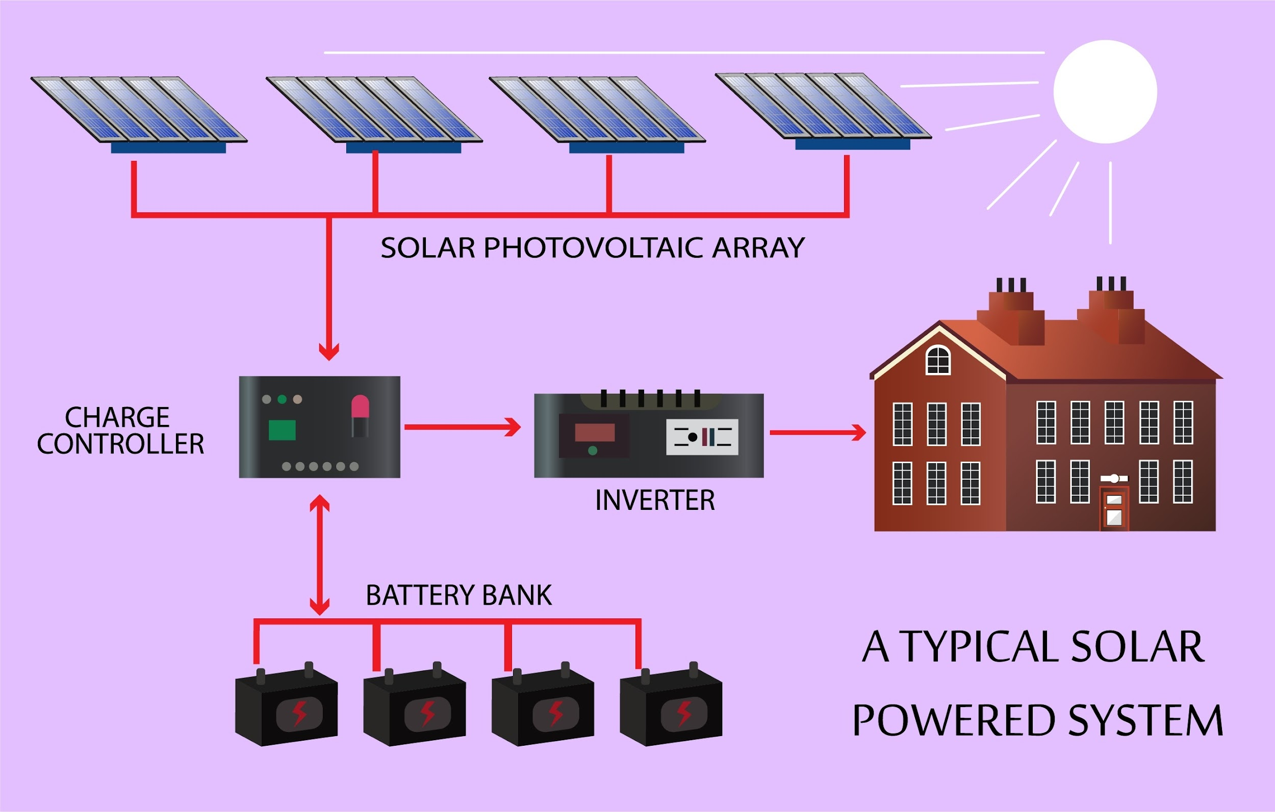
Shutterstock
- Why Go Solar?
  - Financial Freedom: mitigate rising energy costs and sell excess power back to the grid (Net Metering).
  - Grid Independence: With battery storage, your home remains powered during city-wide blackouts.
  - Environmental Impact: A typical residential solar system offsets 3-4 tons of carbon emissions annually.
Page: energy_lighting.html
Structural Instructions:
- Comparison Table: This is the perfect place to use a <table>. Use <thead> for column titles (Type, Lifespan, Cost) and <tbody> for the data.
- Highlight Box: Use an <aside> or a <div> with a specific class (e.g., "tip-box") for the "Buying Tip".
Expanded Content:
- Headline: Lighting the Future: LED Technology
- Content: Lighting accounts for nearly 15% of an average home's electricity use. The switch from incandescent to Light Emitting Diodes (LED) is the single simplest change with the highest ROI (Return on Investment).
- Buying Tip (For the <aside>): When buying LEDs, look for "Lumens" (brightness), not "Watts" (energy use). A 800-lumen LED replaces a 60-watt incandescent bulb but uses only about 9 watts.

♻️ DEV 2: Module WASTE
Page: waste_compost.html
Structural Instructions:
- Step-by-Step Guide: Use an Ordered List (<ol>) for the "How to Start" section so the steps are numbered 1, 2, 3.
- The Lists: Use two Unordered Lists (<ul>) side-by-side to contrast "Greens" vs. "Browns".
Expanded Content:
- Headline: The Art of Composting
- Concept: Composting is the controlled decomposition of organic material. It transforms "trash" into "black gold"—a nutrient-rich soil additive.
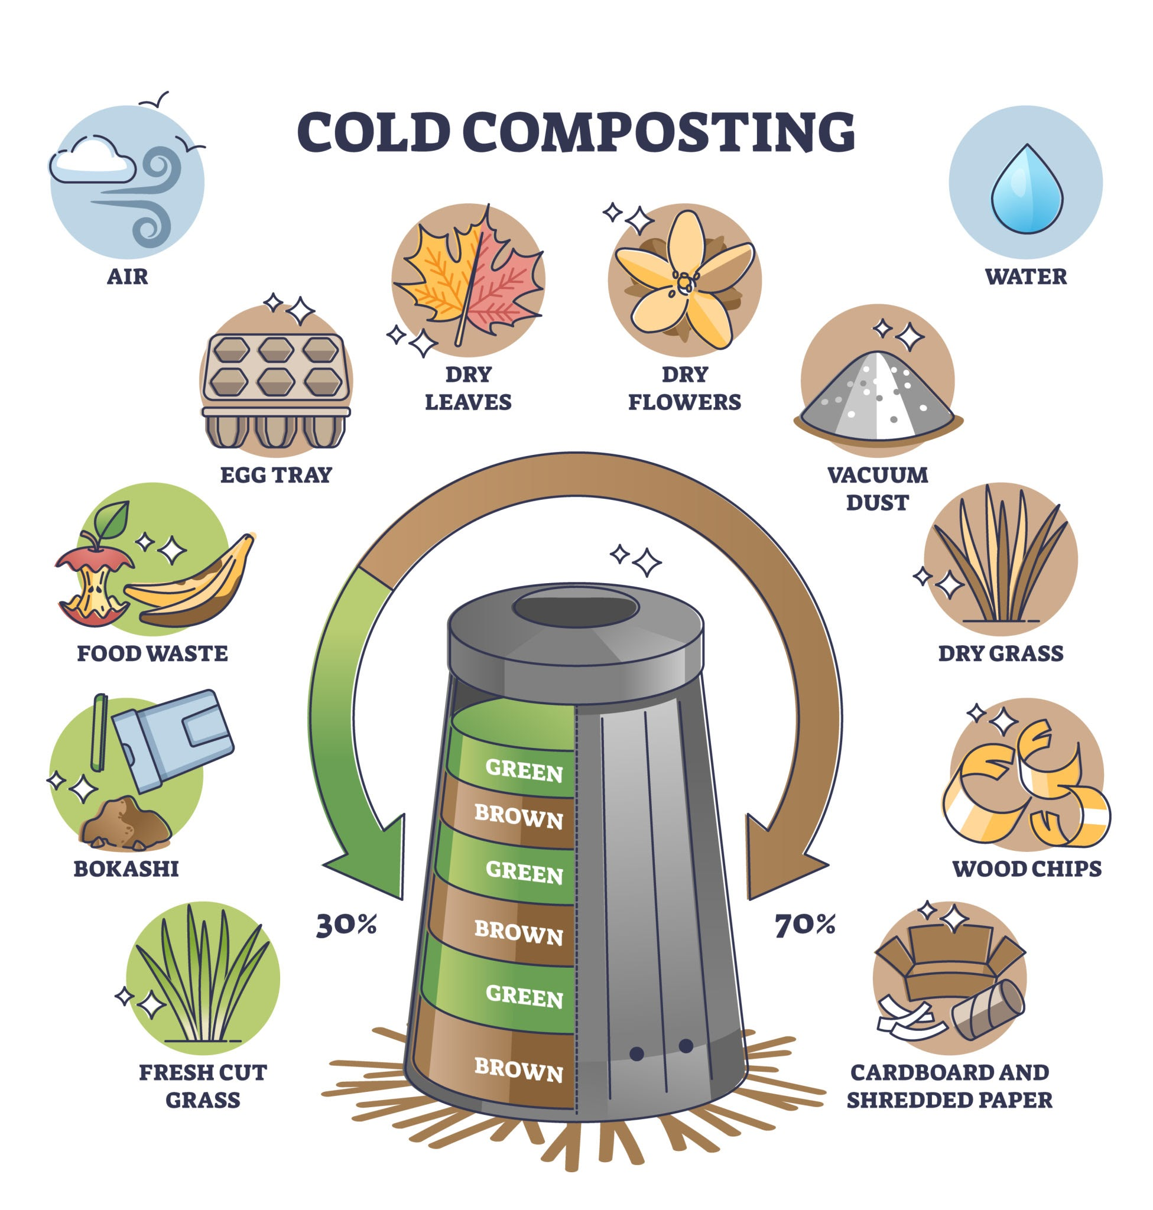
Getty Images
- The Ingredients:
  - Greens (Nitrogen): Vegetable peelings, fruit scraps, coffee grounds, fresh grass clippings.
  - Browns (Carbon): Dry leaves, twigs, shredded newspaper, cardboard, sawdust.
- The Process (Steps):
  - Select a dry, shady spot near a water source.
  - Add brown and green materials in alternate layers.
  - Moisten the pile (it should feel like a wrung-out sponge).
  - Turn the pile every few weeks to aerate.
Page: waste_recycling_rules.html
Structural Instructions:
- Grid Layout: Use a series of <div> elements or <article> tags to create cards for each plastic code (#1, #2, etc.).
- Warning Section: Use a <blockquote> or a bold paragraph <p><strong> for the "Contamination Rule."
Expanded Content:
- Headline: Decoding Recycling Symbols
- The Contamination Rule: "When in doubt, throw it out." Putting non-recyclable items (like greasy pizza boxes) into the bin can contaminate the entire truckload, sending it all to the landfill.
- Code #1 (PETE): Clear plastic bottles. Status: Highly Recyclable.
- Code #2 (HDPE): Milk jugs, detergent bottles. Status: Highly Recyclable.
- Code #6 (PS): Styrofoam/Polystyrene. Status: NOT Recyclable in curbside bins.

💧 DEV 3: Module WATER
Page: water_harvesting.html
Structural Instructions:
- Semantic Structure: Use <article> for the main story.
- Checklist: Use a list <ul> with checkmark styling (handled in CSS, but structure is just <li>) for "System Components."
- Link: Use an anchor tag <a> to link to the Water Filtration page for safety warnings.
Expanded Content:
- Headline: Rainwater Harvesting Systems
- Introduction: Just 1 inch of rain on a 1,000 sq ft roof yields over 600 gallons of water. Harvesting this water is a free way to keep your garden green during dry spells.
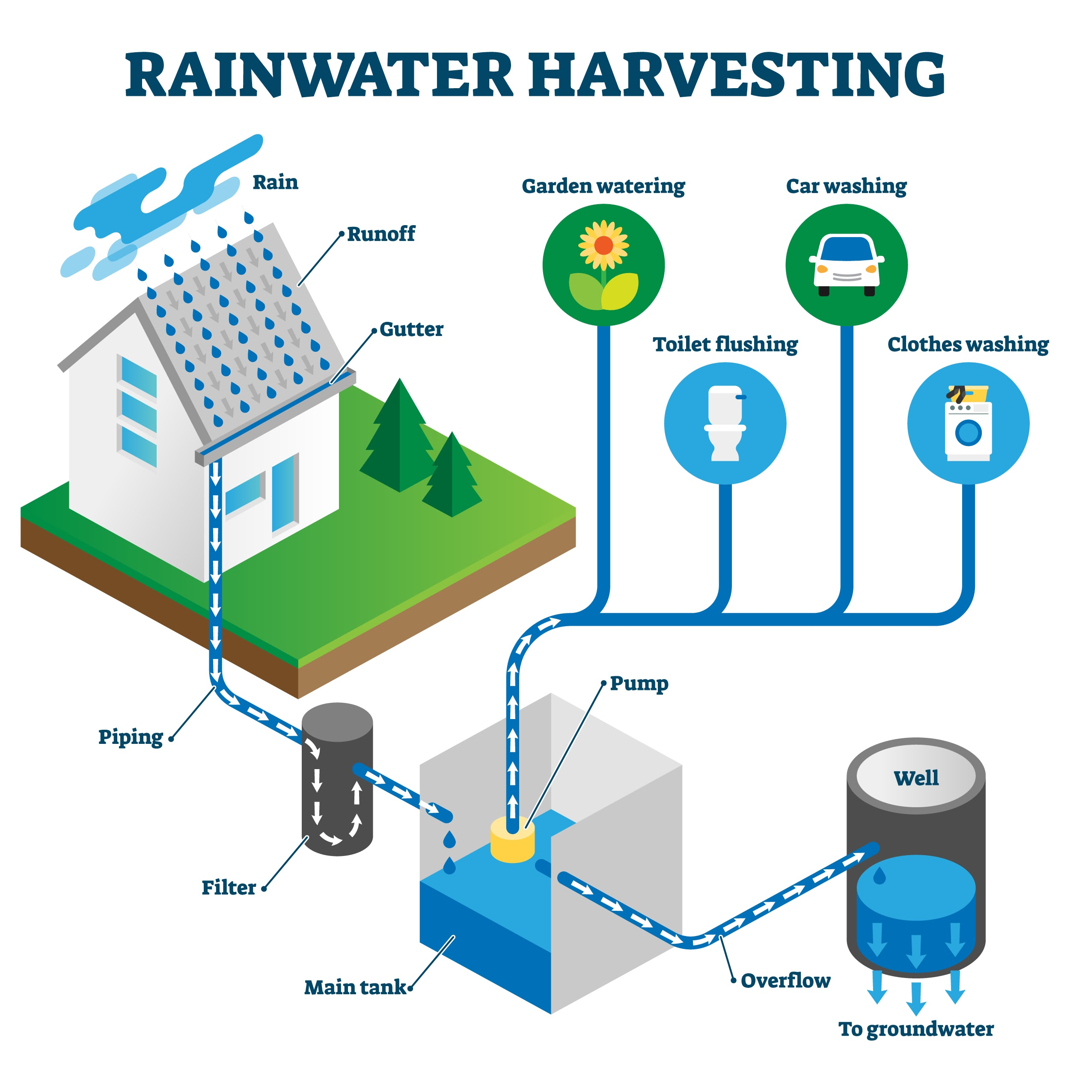
Shutterstock
- System Components:
  - Catchment Area: Usually the roof surface.
  - Conveyance: Gutters and downspouts.
  - Filtration: A "first-flush diverter" removes the initial debris.
  - Storage: Cisterns or rain barrels.
Page: water_drought.html
Structural Instructions:
- Data Presentation: Use a <table> or a series of <div> bars to represent the "Water Footprint" of different foods visually.
- Emphasis: Use <em> or <strong> tags to highlight shocking statistics.
Expanded Content:
- Headline: Your Invisible Water Footprint
- Concept: We consume water in two ways: direct (tap) and indirect (virtual). Virtual water is the hidden volume used to manufacture products.
- The Cost of Consumption:
  - 1 Cotton T-Shirt = 2,700 Liters of water.
  - 1 Cup of Coffee = 140 Liters of water.
  - 1 Pair of Jeans = 10,000 Liters of water.
- Action: Buying second-hand clothes and reducing meat consumption are the most effective ways to lower your water footprint.

🚲 DEV 4: Module TRANSPORT
Page: transport_ev_guide.html
Structural Instructions:
- Tabular Data: A <table> is essential here to compare BEV vs. PHEV.
- Headings: Use <h3> for each vehicle type.
- Details: Use <details> and <summary> tags for an interactive FAQ section (e.g., "How long does charging take?").
Expanded Content:
- Headline: Electric Vehicles (EVs) Explained
- BEV (Battery Electric Vehicle): Runs 100% on electricity. Zero tailpipe emissions. Range: 200–400 miles. Ideal for: Daily commuters and city driving.
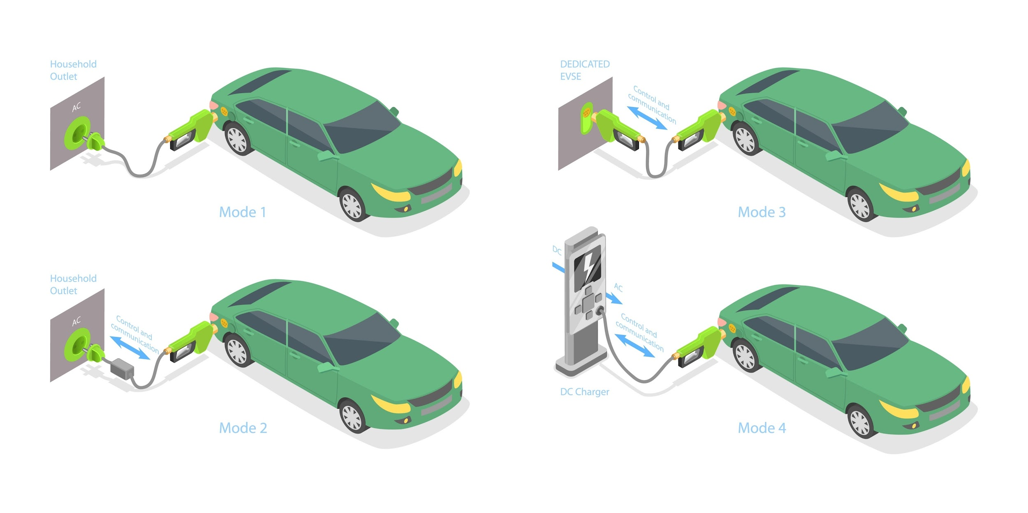
Shutterstock
- PHEV (Plug-in Hybrid): Combines a battery (20–50 mile range) with a gas engine. Ideal for: People with "range anxiety" or those who frequently drive long distances in rural areas.
- Charging Levels:
  - Level 1: Standard wall outlet (slow).
  - Level 2: Dryer-outlet voltage (overnight full charge).
  - Level 3: DC Fast Charge (80% in 30 mins).
Page: transport_biking.html
Structural Instructions:
- Safety Section: Use a <section> with a distinct class. Use <ul> for the gear list.
- Image: Use an <img> tag to show proper helmet fit.
Expanded Content:
- Headline: Commuting on Two Wheels
- Health & Planet: Biking burns calories, not fossil fuels. It is the most energy-efficient form of transport ever invented.
- Essential Safety Gear:
  - Helmet: Must sit level on your head, not tilted back.
  - Lights: White front light and red rear light (flashing is best for visibility).
  - Lock: A U-Lock is safer than a cable lock.
- Traffic Laws: Cyclists are vehicles. You must stop at stop signs and ride in the same direction as traffic.

🥗 DEV 5: Module LIFESTYLE
Page: life_seasonal_eating.html
Structural Instructions:
- Seasonal Grid: Use a flexible grid layout (parent <div> with child <div> items) to show the four seasons.
- Lists: Inside each season <div>, use a <ul> to list the vegetables.
Expanded Content:
- Headline: The Benefits of Seasonal Eating
- Why It Matters: Out-of-season food (e.g., strawberries in winter) requires energy-intensive greenhouses or air-freight shipping from the other side of the world. Seasonal food is cheaper, nutrient-dense, and supports local farmers.
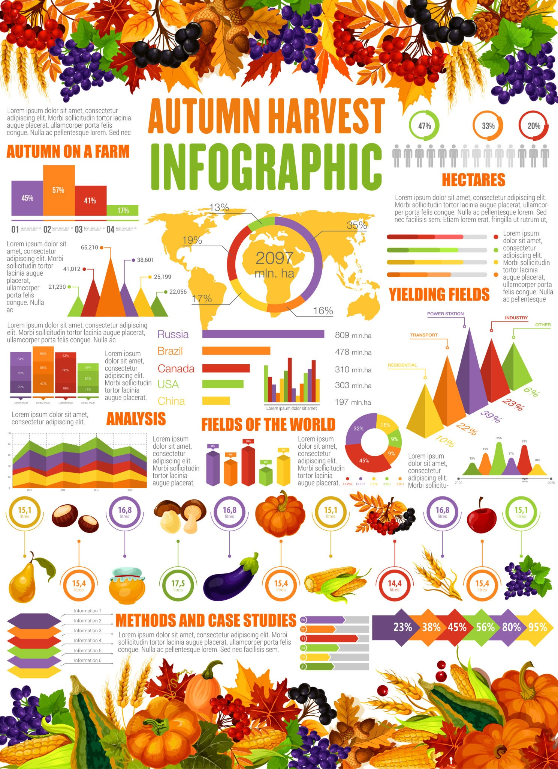
Getty Images
- Spring: Asparagus, Spinach, Peas, Radishes.
- Summer: Tomatoes, Berries, Corn, Zucchini, Melons.
- Autumn: Pumpkins, Apples, Squash, Sweet Potatoes.
- Winter: Root vegetables, Citrus, Kale, Brussels Sprouts.
Page: life_fast_fashion.html
Structural Instructions:
- Article Flow: Use <h2> for main sections and <p> for text.
- Callout Quote: Use a <blockquote> for a powerful statement about textile waste.
- External Links: Use <a> tags (with target="_blank") to link to sources or ethical brand directories.
Expanded Content:
- Headline: The High Cost of Cheap Clothes
- The Problem: The fashion industry produces 10% of all humanity's carbon emissions and is the second-largest consumer of the world's water supply. "Fast Fashion" brands release new collections weekly, encouraging a "wear once and throw away" culture.
- Synthetic Fibers: Polyester and nylon are plastic. Washing them releases microplastics into our oceans, which enter the food chain.
- The Solution:
  - Buy Less: The most sustainable garment is the one already in your closet.
  - Repair: Learn basic sewing to fix buttons and tears.
  - Thrift: Buying second-hand extends the life of a garment and prevents landfill waste.
_________________________________________________________________________

⚡ DEV 1: Module ENERGY (Remaining Pages)

3. Page: energy_insulation.html
Topic: Home insulation tips.
- Structure/Tags:
  - Visual Explanation: Use a <figure> with an <img> to show "Heat Loss in a House" (e.g., heat escaping through the roof).
  - List of Areas: Use an Unordered List <ul> for the "Key Zones" (Attic, Walls, Windows).
  - Pro-Tip Box: Use a <div> with a class like .alert or .tip for the "Draft Snake" DIY tip.
- Content:
  - Headline: Stop the Leak: Mastering Home Insulation.
  - Intro: Heat flows from warm to cool areas. In winter, it escapes; in summer, it invades. Proper insulation acts as a barrier, reducing the workload on your heating and cooling systems.
  - Key Zones to Check:
    - Attic: Heat rises. A poorly insulated attic is the #1 source of energy loss.
    - Windows: Single-pane windows are energy holes. Use weatherstripping or double-glazing.
    - Doors: Gaps under doors let drafts in.
  - DIY Tip: Use a "draft snake" (a fabric tube filled with rice or beans) at the bottom of drafty doors to instantly stop air leaks.

4. Page: energy_monitor.html
Topic: Smart meters/monitoring.
- Structure/Tags:
  - Definition: Use <dl> (Definition List) for terms like "Smart Meter" and "Kill-A-Watt".
  - Graph/Chart Placeholder: Use a <div> styled as a placeholder for a usage graph.
  - Action List: Use <ol> for the "How to Audit" steps.
- Content:
  - Headline: Smart Monitoring: See Your Usage .
  - Concept: You can't manage what you don't measure. Smart meters send digital readings to your supplier, but they also give you real-time data on your consumption.
  - The "Vampire" Hunt: Many devices draw power even when "off" (TVs, chargers). A simple plug-in monitor (like a Kill-A-Watt) can show you exactly which appliance is draining your wallet.
  - 3 Steps to Audit: 1. Check your bill graph for spikes. 2. Monitor individual appliances. 3. Unplug "vampires" or use smart power strips.

5. Page: energy_tips.html
Topic: General energy-saving checklist.
- Structure/Tags:
  - Checklist: Use a <form> structure with <input type="checkbox"> and <label> tags to make it look like a real interactive checklist (even if it doesn't submit anywhere).
  - Categories: Use <fieldset> to group tips by room (Kitchen, Living Room, Laundry).
- Content:
  - Headline: Your Daily Energy-Saving Checklist.
  - Kitchen: [ ] Keep the fridge full (solids retain cold better than air). [ ] Boil only the water you need in the kettle.
  - Laundry: [ ] Wash clothes at 30°C (cold wash). [ ] Air dry clothes instead of using the dryer.
  - General: [ ] Turn off lights when leaving a room. [ ] Lower thermostat by 1°C.

♻️ DEV 2: Module WASTE (Remaining Pages)

3. Page: waste_upcycling.html
Topic: DIY upcycling projects.
- Structure/Tags:
  - Project Cards: Use <article> tags for each project idea.
  - Materials List: Inside each article, use a <ul> for "What you need."
  - Instructions: Use <ol> for the step-by-step creation process.
- Content:
  - Headline: Trash to Treasure: Beginner Upcycling Projects.
  - Project 1: T-Shirt Tote Bag. Need: Old T-shirt, Scissors. Steps: Cut off sleeves and neckline. Cut fringe at the bottom. Tie fringe knots to close the bag. No sewing needed!
  - Project 2: Jar Organizers. Need: Empty pasta sauce jars. Steps: Wash thoroughly. Paint lids. Use for storing nails, spices, or office supplies.

4. Page: waste_plastic_alts.html
Topic: Alternatives to single-use plastic.
- Structure/Tags:
  - Comparison Grid: Use a CSS Grid layout (parent <div>, child <div>s) to show "Swap This" vs. "For That."
  - Images: Essential here. Use <img> tags for the eco-friendly products.
- Content:
  - Headline: Breaking the Plastic Habit.
  - The Problem: Single-use plastics differ from durable plastics; they are used for minutes but last for centuries .
  - Easy Swaps:
    - Plastic Straws -> Metal/Bamboo Straws.
    - Cling Film -> Beeswax Wraps.
    - Liquid Shampoo -> Shampoo Bars.
    - Plastic Toothbrush -> Bamboo Toothbrush.

5. Page: waste_hazards.html
Topic: Disposing of batteries/electronics.
- Structure/Tags:
  - Warning Box: Use a <div> with a red border/background style (class .danger) for "NEVER BIN THESE."
  - Icon List: Use <ul> with specific classes to add icons for batteries, bulbs, and phones.
  - External Link: Use <a href="..." target="_blank"> to "Find a Drop-off Site."
- Content:
  - Headline: Hazardous Waste: Handle with Care.
  - The Dangers: Batteries and electronics (e-waste) contain heavy metals like lead, mercury, and cadmium. If buried in landfills, these leak into the soil and groundwater.
  - Items to Separate: Batteries (AA, Lithium), CFL Lightbulbs (contain mercury), Old Phones/Laptops, Paint/Chemicals.
  - Disposal: Look for "Take-Back" schemes at electronics stores or visit your municipal hazardous waste center.

💧 DEV 3: Module WATER (Remaining Pages)

3. Page: water_fixtures.html
Topic: Low-flow taps/showers.
- Structure/Tags:
  - Comparison: Use a <div> split view to compare "Old Showerhead (15L/min)" vs "Low-Flow (7L/min)".
  - Savings Calculator: Use a visual block that states "You save X liters per year."
- Content:
  - Headline: Upgrade Your Fixtures, Save the Planet.
  - The Tech: "Low-flow" doesn't mean low pressure. Aerators mix air into the water stream, maintaining the feeling of high pressure while using 50% less water.
  - Top Upgrades:
    - Faucet Aerators: Cheap ($5) and screw onto existing taps.
    - Dual-Flush Toilets: Choose between a half-flush for liquids and full-flush for solids.

4. Page: water_garden.html
Topic: Drought-resistant plants.
- Structure/Tags:
  - Gallery: Use <figure> tags with <img> and <figcaption> for plant names.
  - Tips List: Use <ul> for maintenance tips.
- Content:
  - Headline: Xeriscaping: Beauty with Less Water.
  - Concept: Why grow thirsty grass in a dry climate? Xeriscaping uses native plants that survive on natural rainfall.
  - Plant Stars:
    - Lavender: Smells great, bees love it, needs almost no water.
    - Succulents/Sedum: Store water in their leaves.
    - Ornamental Grasses: Hardy and add texture to the garden.
  - Mulching: Always cover soil with bark or straw to stop evaporation.

5. Page: water_filtration.html
Topic: Home filtration systems.
- Structure/Tags:
  - Accordion/Details: Use <details> and <summary> for each filter type (Carbon, RO, UV) to keep the page clean.
  - Pros/Cons: Inside the details, use bullet points.
- Content:
  - Headline: Clean Water Without the Bottles.
  - Why Filter? Tap water is generally safe, but old pipes can add lead, and chlorine affects taste. Bottled water generates massive plastic waste.
  - Types:
    - Activated Carbon (Pitchers): Cheap, removes chlorine/taste. Change filter monthly.
    - Reverse Osmosis (Under-sink): Removes almost everything (fluoride, lead). Expensive and wastes some water during filtration.
    - Ceramic: Good for removing bacteria and sediment.

🚲 DEV 4: Module TRANSPORT (Remaining Pages)

3. Page: transport_public.html
Topic: Bus/Train benefits.
- Structure/Tags:
  - Stat Highlight: Use <h1> or <h2> for big numbers (e.g., "1 Bus = 40 Cars").
  - Scenario: Use a <div> titled "The Commute Off" comparing a driver vs. a rider.
- Content:
  - Headline: The Power of Public Transit .
  - Efficiency: Moving 50 people in one vehicle is infinitely more efficient than moving 50 vehicles.
  - Personal Benefits:
    - Cost: No gas, insurance, or parking fees.
    - Productivity: Read, sleep, or work while you ride.
    - Safety: Buses and trains have significantly lower accident rates than private cars.

4. Page: transport_carpool.html
Topic: Carpooling tips/apps.
- Structure/Tags:
  - Step Guide: Use <ol> for "How to setup a carpool."
  - Etiquette Box: Use a <blockquote> or styled <div> for "Carpool Etiquette."
- Content:
  - Headline: Share the Ride, Split the Cost.
  - The Math: Driving alone is the most expensive way to travel. Adding just one passenger cuts your fuel costs by 50%.
  - Finding a Ride: Use apps like BlaBlaCar, Waze Carpool, or workplace noticeboards.
  - Etiquette: be punctual (don't make others wait), agree on music/radio beforehand, and settle payments (gas money) promptly.

5. Page: transport_walking.html
Topic: Walkability scores/health.
- Structure/Tags:
  - Definition: Use <p class="lead"> for the "15-Minute City" concept.
  - Health Benefits: Use <ul> list.
  - Link: Provide a link to a "Walk Score" calculator.
- Content:
  - Headline: Walking: The Zero-Carbon Commute.
  - The 15-Minute City: The ideal sustainable neighborhood is one where you can reach the grocery store, park, and school within a 15-minute walk.
  - Health Wins: 30 minutes of walking daily reduces heart disease risk by 19%. It also boosts mental health and clears the mind.
  - Check Your Score: Does your neighborhood have sidewalks? Safe crossings? Street trees? These factors determine your "Walkability Score."

🥗 DEV 5: Module LIFESTYLE (Remaining Pages)

3. Page: life_urban_farming.html
Topic: Balcony gardening.
- Structure/Tags:
  - Grid: Use a 2x2 grid of <div>s for "Best Plants for Small Spaces."
  - Vertical Guide: Use a vertical layout description.
- Content:
  - Headline: Farming Concrete: The Urban Garden.
  - No Land? No Problem. You don't need a backyard. Windowsills, balconies, and even fire escapes can grow food.
  - Top Small-Space Crops:
    - Herbs (Basil, Mint): Grow easily in small pots on a sunny sill.
    - Leafy Greens: Lettuce and spinach have shallow roots, perfect for trays.
    - Cherry Tomatoes: Grow vertically in hanging baskets.
  - Vertical Gardening: Use wall pockets or trellises to grow up instead of out.

4. Page: life_ethical_shopping.html
Topic: Fair trade/Greenwashing.
- Structure/Tags:
  - Contrast Table: A <table> comparing "Ethical" vs. "Fast" production.
  - Logo Showcase: Use <img> tags for Fair Trade, B-Corp, and Organic logos (find generic placeholders or descriptions).
- Content:
  - Headline: Vote with Your Wallet.
  - What is Fair Trade? It ensures that the farmers and workers who produce our goods are paid a living wage and work in safe conditions.
  - Beware Greenwashing: Marketing that uses green colors and words like "natural" but lacks certification. Always look for the stamp:
    - USDA Organic / EU Leaf: Certified chemical-free.
    - Fair Trade Certified: Ethical labor.
    - B-Corp: Company meets high social/environmental standards.

5. Page: life_meat_impact.html
Topic: Food carbon footprint comparison.
- Structure/Tags:
  - Bar Chart: Use HTML/CSS to create simple horizontal bars (using <div>s with percentage widths) representing carbon impact.
  - Impact list: Use <ul>.
- Content:
  - Headline: The Carbon Footprint of Your Plate .
  - The Data: Food production accounts for 26% of global greenhouse gas emissions.
  - Comparison (Kg CO2 per Kg of Food):
    - Beef: ~60kg CO2 (High Impact)
    - Cheese: ~21kg CO2
    - Chicken: ~6kg CO2
    - Beans/Peas: ~1kg CO2 (Low Impact)
  - The Flexitarian Approach: You don't have to go fully vegan. Simply swapping beef for chicken, or doing "Meatless Mondays," significantly lowers your impact.
_________________________________________________________________________
I have created a list of image search prompts for every page.
According to your Workflow Procedure¹, you are required to "Collect images (Pexels/Unsplash) and save them" into your images/ folder. Use the Search Queries below on sites like Pexels, Unsplash, or Pixabay to find high-quality free images.
I have also included the Alt Text you should use in your HTML <img> tags, as this is crucial for accessibility marks.

👑 LEADER: General Pages
Page | Image Concept | Search Query (Pexels/Unsplash) | Alt Text Recommendation
index.html | A futuristic, green, eco-friendly city skyline (Hero Image). | "Green city futuristic vertical garden" | alt="Futuristic sustainable city skyline with vertical gardens"
news.html | (Article 1) Wind turbines or solar farm. | "Wind turbine sunset" | alt="Wind turbines generating renewable energy"
news.html | (Article 2) Electronics being repaired or e-waste recycling. | "Repairing electronics" | alt="Technician repairing a smartphone"
about_sustainability.html | Hands holding a small plant or soil. | "Hands holding plant soil" | alt="Hands cradling a young plant in soil"

⚡ DEV 1: Module ENERGY
Page | Image Concept | Search Query | Alt Text Recommendation
energy_solar.html | Rooftop solar panels on a residential house. | "Solar panels house roof" | alt="Modern home with rooftop solar panels"
energy_insulation.html | Pink or yellow fiberglass insulation rolls or an attic. | "Attic insulation fiberglass" | alt="Rolls of fiberglass insulation material"
energy_lighting.html | A comparison or lineup of LED bulbs. | "LED light bulb" | alt="Energy-efficient LED light bulb"
energy_monitor.html | A smart meter digital display or a smart thermostat. | "Smart thermostat wall" | alt="Digital smart thermostat displaying temperature"
energy_tips.html | Someone washing clothes or a line of laundry drying outside. | "Laundry drying outside sunny" | alt="Clothes drying naturally on a clothesline"

♻️ DEV 2: Module WASTE
Page | Image Concept | Search Query | Alt Text Recommendation
waste_compost.html | Close up of rich dark compost soil or a compost bin. | "Compost soil hands" | alt="Rich organic compost soil"
waste_recycling_rules.html | Colored recycling bins (Blue/Green/Yellow). | "Recycling bins color coded" | alt="Row of color-coded recycling bins"
waste_upcycling.html | A DIY craft project (e.g., jar lanterns or painted furniture). | "DIY painted glass jars" | alt="Upcycled glass jars used as decor"
waste_plastic_alts.html | Reusable items: Metal straw, bamboo toothbrush, or tote bag. | "Zero waste lifestyle products" | alt="Bamboo toothbrush and reusable metal straw"
waste_hazards.html | A pile of old batteries or e-waste (old phones/cables). | "Old batteries pile" | alt="Pile of used batteries and electronic waste"

💧 DEV 3: Module WATER
Page | Image Concept | Search Query | Alt Text Recommendation
water_harvesting.html | A rain barrel connected to a gutter downspout. | "Rain barrel garden" | alt="Rain barrel collecting water from a gutter"
water_fixtures.html | A modern bathroom faucet or showerhead. | "Modern bathroom faucet water" | alt="Low-flow water faucet running"
water_garden.html | A xeriscape garden with succulents and rocks (no grass). | "Xeriscape garden succulents" | alt="Drought-resistant garden with succulents and stones"
water_filtration.html | A glass pitcher of water with a filter or a kitchen tap filter. | "Water filter pitcher pouring" | alt="Pouring water from a filtration pitcher"
water_drought.html | Cracked dry earth or a dry riverbed. | "Drought dry cracked earth" | alt="Cracked dry earth due to drought"

🚲 DEV 4: Module TRANSPORT
Page | Image Concept | Search Query | Alt Text Recommendation
transport_ev_guide.html | An electric car plugged into a charging station. | "Electric car charging" | alt="Electric vehicle plugged into a charging station"
transport_biking.html | A cyclist riding in a city bike lane wearing a helmet. | "Urban cyclist helmet" | alt="Cyclist commuting in a city bike lane"
transport_public.html | People waiting for or boarding a modern bus/train. | "Public transport bus stop" | alt="Commuters boarding a city bus"
transport_carpool.html | A group of happy people driving in one car. | "Friends driving car road trip" | alt="Group of people carpooling together"
transport_walking.html | People walking in a park or on a sidewalk. | "People walking city park" | alt="Pedestrians walking on a tree-lined path"

🥗 DEV 5: Module LIFESTYLE
Page | Image Concept | Search Query | Alt Text Recommendation
life_seasonal_eating.html | A basket of fresh seasonal vegetables (pumpkins, greens, etc.). | "Farmers market vegetables" | alt="Fresh seasonal vegetables at a market"
life_fast_fashion.html | A pile of discarded clothes or a thrift store rack. | "Clothing pile waste" | alt="Pile of discarded fast-fashion clothing"
life_urban_farming.html | Pots of herbs on a balcony or windowsill. | "Balcony garden apartment" | alt="Potted herbs growing on an apartment balcony"
life_ethical_shopping.html | A 'Fair Trade' or 'Organic' label/stamp on a product. | "Organic food label" | alt="Product with certified organic label"
life_meat_impact.html | A visual comparison of a burger vs. a salad or veggies. | "Healthy plant based meal" | alt="Fresh plant-based meal ingredients"

🛠️ Technical Tip for Images
When you save these images, rename them to match the page topic so they are easy to link.
- Bad Name: pexels-photo-12345.jpg
- Good Name: solar_panels_roof.jpg
HTML Example:
HTML
<figure>
<img src="../../images/solar_panels_roof.jpg" alt="Modern home with rooftop solar panels">
<figcaption>Solar panels can reduce electricity bills by up to 50%.</figcaption>
</figure>

